Title of Abstract / Full paper (max. 2 lines)
Forename Surname, Forename Surname, Forename Surname

Introduction
To make sure that the documents have high quality, all full paper will be reviewed by the organization committee. The full paper should describe the topic including introduction, material and methods, results, and discussion. You can use figures and diagrams to improve your full paper.
- The standard font type is Times (New) Roman for all titles and text. Paper title and all section titles are using bold fonts.
- The font size for the body text is 11 pt. The line spacing is 12 pt.
- The Full paper shall be around 4 to 8 pages, longer papers are possible.
- The file’s name must be “ICTB2021-Surname of corresponding author.pdf” (e.g. ICTB2021–Franke.pdf).
- Deadline of Abstract is 20 December 2021 via email ictb21@bfh.ch
- Deadline of Full paper submission is 1st March 2022, via email ictb21@bfh.ch

Material and method
A summary of the results should be given and discussed. Tables or figures can be used as shown in Figure 1 and Table 1, equations should be numbered.

Results

First test series

General
Text text text text text text text text text text text text text text text text text text text text text text text text text text text text text text text text text text text text text text text text text text text text text text text text text text text text text text text

Details
Text text text text text text text text text text text text text text text text text text text text text text text text text text text text text text text text text text text text text text text text text text text text text text text text text text text text text text text

Second test series
Text text text text text text text text text text text text text text text text text text text text text text text text text text text text text text text text text text text text text text text text text text text text text text text text text text text text text text text
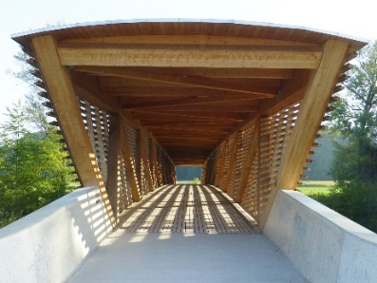
Figure 1: Bridge – Neumatt, Burgdorf, Switzerland

Table 1: Table example
Column 1 | Column 2
Content 1 | Content2
… | …

Acknowledgement
Text, text, text, text, text, text, text, text, text, text, text, text, text, text, text, text, text, text, text

References
- Bathe K.-J. (2002) Finite-Elemente-Methoden. Springer-Verlag Berlin Heidelberg New York.
- Mahnken R. (1995) A Newton-multigrid algorithm for elasto-plastic/viscoplastic problems. Comp. Mechs., 15:408-425.
- Zener C., Hollomon J. H. (1944) Effect of strain rate upon plastic flow of steel. Journal of Applied Physics, 15(1):22-32.
- Johnson G. R., Cook W. H. (1983) A constitutive model and data for metals subjected to large strains, high strain rates and high temperatures. In: 7th International Symposium on Ballistics, 514-546.
- Bonte M. H. A., van den Boogaard A. H., Huétink J. (2007) A metamodel based optimisation algorithm for metal forming processes. In: D. Banabic, editor, Advanced Methods in Material Forming, pages 55–72. Springer Verlag, Heidelberg, Germany.

Corresponding Author, Position, Institute, Country, Corresponding Email

